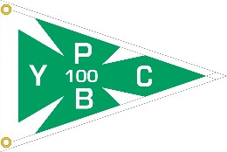
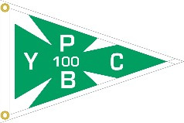
Pine Beach Yacht Club
2018 Junior Sailing Program Application

_________________________________________________________________________________

Welcome to the 2018 Junior Sailing Program! We are excited that you plan to spend your summer with us. The completion of this form and a tuition deposit will hold a place for your child in our program. A mandatory parents meeting will be held on Sunday, June 10th at 10:30 am. Sailors should plan to have their boats at the club for this meeting so that instructors can look them over for any concerns and/or missing equipment. All forms (additional paperwork will be emailed to you once your application is processed) and final tuition payments will be due at this meeting.

As of right now, the program is scheduled to run for 8 weeks from June 25th - August 16th,
Mondays through Thursdays. Awards Night is tentatively scheduled for the evening of Friday, August 17th. If the school year is extended or reduced due to snow days, the start and end dates may to change plus or minus one week based on the final day of school.

GENERAL INFORMATION:
All Junior Sailing notices will be sent via e-mail. Questions regarding junior sailing should be directed to the parent coordinator, April Krajewski, by phone at 732-575-2014 or via email to aprilkrajewski@hotmail.com.

BOATS:
The club does not provide boats. Participants must provide their own boat. Crewing positions must be worked out between the boat owner (skipper) and any crew. Any questions, please ask.

LOCKERS:
Lockers are available on a first come, first served basis. For locker information, please email our Rear Commodore, Russ Whitman, at whitmansangels@comcast.net.

PBYC MEMBERSHIP:
For information regarding membership, please visit our website at www.pbycnj.com or email our Membership Chairman, Tom Herman, at membership@pbycnj.com.

RACING AND RECREATION:
The PBYC Junior sailing program prides itself on offering something for everyone. We offer programs for beginner, recreational as well as racing-minded sailors.

The “Pre-Opti” and “River Rat” programs are designed for our youngest sailors. The “River Rat” program does NOT require the sailor to have a boat, but the “Pre-Opti” program does. These programs will meet twice a week on alternating days. The “Pre-Opti” program is NOT a prerequisite for the “Beginner” program.

Beginner sailors and recreational sailors will sail from 8:30-12:30 Monday through Thursday. Morning (8:30-12:30) sailors will focus on sailing fundamentals, concentrate on sailing as a recreational activity more than a sport, and will gain a basic knowledge of racing.

Our sailors most interested in racing will sail from 8:30-2:00 each day. These sailors will take a
short break for lunch around 11:45 am and then head back out to practice racing drills in the afternoon sea breeze. This extra practice in the afternoon should give sailors a better opportunity to sail in conditions likely to be found during regattas and interclubs. In order to sail in this group, sailors should have at least one year of sailing experience, participated in interclub and regattas the previous year, be enthusiastic about sailing in heavier winds and in the bay, and have an eagerness to learn new skills and racing techniques. These sailors should bring a bagged lunch or a large snack each day.

REGISTRATION DEPOSIT: This pre-registration process is extremely important to ensure proper hiring and staffing of the program. There is a $100.00 non-refundable deposit due by April 15th to reserve your space. Space may be limited. Class size will be limited. Sailors will be grouped according to skill level. All balances must be paid in full by the June 10th parent meeting! A $50 late fee will be charged for all registrations received after 4/15/18. Placement is based on a first come, first served basis.

We need parents to be involved to offer all of the activities we have planned. Parents are required to volunteer for at least one activity. There will be signup sheets at the parent meeting. THANK YOU in advance for getting INVOLVED!!! Your dedication and assistance are very much appreciated.

Sailing Fleets
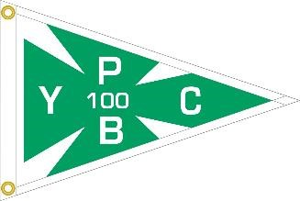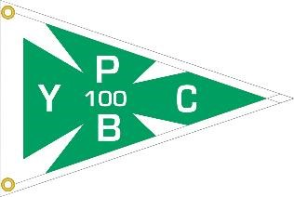

Class | Program Length | Member Fee | Non-Member Fee
Laser, Opti, or Sunfish  Recreational Focus (ages 8-17) | Mon-Thurs 6/25-8/16 8:30-12:30 | $600 $650 (after 4/15) | $1400  $1450 (after 4/15)
Laser, Opti, or Sunfish  Racing Focus  (ages 8-17) | Mon-Thurs 6/25-8/16 8:30-2:00 | $750 $800 (after 4/15) | $1700 $1750 (after 4/15)
Pre-Opti (ages 7-8) | Tuesdays and Thursdays  6/26-8/16  9:00-12:00 | $325  $375 (after 4/15) | $650  $700 (after 4/15)
River Rats  Land-Based Program (age 6-7) | Mondays and Wednesdays  6/25-8/16  9:00-11:30 | $275  $300 (after 4/15) | $375  $400 (after 4/15)

Pine Beach Yacht Club
2018 Junior Sailing Program
Registration / Deposit Form
_________________________________________________________________________________
Please return this form and the deposit. Checks should be made payable to PBYC. Credit card payments can only be accepted by using the form available on our website www.pbycnj.com. Please do NOT include any credit card information on this form. Please mail payments to: PBYC, P.O. Box 301; Pine Beach, NJ 08741. Please list your child’s name and “Junior Sailing” in the memo. Please return registration forms to the junior sailing coordinator, April Krajewski, by mailing your form to: 813 Radnor Avenue; Pine Beach, NJ 08741. If you would like to enroll multiple children, please use a new form for each child. This form and deposit are due by April 15, 2018.

Child’s Name:_____________________________________________ Date of Birth:______________

Names of Parents or Guardians: _________________________________________________________

Address:__________________________________________________________________________

MANDATORY e-mail: _________________________________________________________________

Phone No.: _____________________ Cell _____________________ Cell ______________________

Fleet and Fleet Day/Time: ___________________________ Boat type: _________________________

Total Fee: $_______________ Deposit Paid: $_______________ Check #_______ or credit card

T-shirt size: (circle one) YM YL AS AM AL AXL

