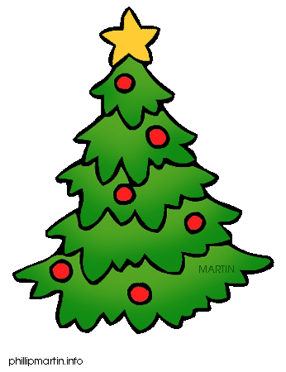

PLEASE JOIN US FOR THE
ANNUAL PBYC
TREE LIGHTING!

Our Happy Holiday Happening
On Saturday, December 15, 2018
At 7 PM at the club
Santa is scheduled to visit!!!

Bar will be OPEN. Please bring a plated appetizer or dessert to share. And please let Donna know what you are bringing.

There will be a raffle. Don’t forget to wear your favorite holiday sweater, vest or hat for the occasion!

Please let Donna Barnett know how many are coming and what you are bringing. Email her at stylebug@comcast.net or call 732-349-0203 no later than December 13!

